BASIC 7
WEEKLY LESSON PLAN – WEEK 2
Strand: | Design |  |  | Sub-Strand: |  |  |  |  | Design in nature and manmade environment
Content Standard: | B7/JHS1 1.1.1 Demonstrate understanding of design as a concept in relation to the elements (dots, lines, and shapes) and principles (balance, rhythm, repetition) of design and as a medium for creative expression of design in nature and the manmade environment.
Indicator (s) | B7/JHS1 1.1.1.2 Research to identify and record what constitutes the ‘elements of design’ in nature and as building blocks for creative expression of design ideas. |  |  |  |  |  | Performance Indicator: Learners can use the elements of design in nature to create designs.
Week Ending | 20-09-2024
Class | B.S.7 |  | Class Size: |  |  |  |  | Duration:
Subject | Creative Art and Design.
Reference | Creative Arts Curriculum, Teachers Resource Pack, Learners Resource Pack.
Teaching / Learning Resources | Posters and Pictures showing natural and manmade things in the environment, Video, Wordchart. |  |  |  |  | Core Competencies: |  |  |  | - Communication and Collaboration  - Critical Thinking  - Creativity and Innovation.
DAY/DATE | PHASE 1 : STARTER | PHASE 2: MAIN |  |  |  |  |  |  |  |  |  | PHASE 3: REFLECTION
MONDAY | Review Learners knowledge on the elements of design.  Learners brainstorm to explain the meaning of ‘Elements of Design”. | - Assist Learners to identify the components of elements of design.  - Discuss 5 examples of natural elements of design and manmade elements of design.  - Learners in small groups to discuss how natural and manmade elements of design as building blocks for creative expression of design.  - Call individual learners in each group at random to report on their discussions.  Elements of Design;  - Line  - Color  - Value  - Shape  - Form  - Space  - texture.  Natural Elements of Design;  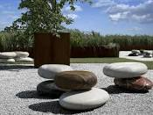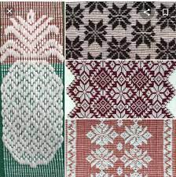  Natural elements shapes Natural elements Pattern  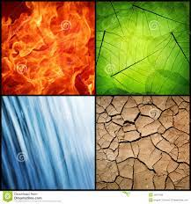  Natural elements colours.  Manmade Elements of Design;  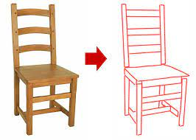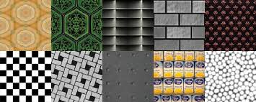 |  |  |  |  |  |  |  |  |  | Reflect on the use of natural and manmade elements of design for creative expression of design.  Exercise;  - State 5 examples of Elements of Design.  - Draw 2 examples each of;  - Natural elements of design  - Manmade elements of design.
THURSDAY | Individual Learners brainstorm to identify examples of elements of design. | - Demonstrate how to create Patterns that reflect on the examples of elements of design identified by the Learners.  - Learners in groups to practice creating patterns with the elements of design.  - Inspect, appreciate and comment on Learners practical work.  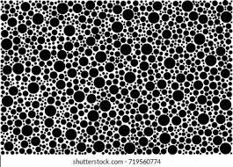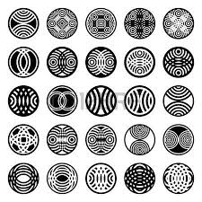  Circles Pattern    Circle Line Pattern  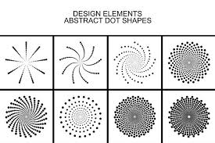 |  |  |  |  |  |  |  |  |  | Through questions and answers, conclude the lesson.  Practical;  Create Pattern using the following elements of design;  - Circle  - Line  - Dot  - Texture.

Name of Teacher: School: District:

