BASIC 7
WEEKLY LESSON PLAN – WEEK 3
Strand: | Design |  |  | Sub-Strand: |  |  |  |  | Design in nature and manmade environment
Content Standard: | B7/JHS1 1.1.1 Demonstrate understanding of design as a concept in relation to the elements (dots, lines, and shapes) and principles (balance, rhythm, repetition) of design and as a medium for creative expression of design in nature and the manmade environment.
Indicator (s) | B7/JHS1 1.1.1.3 Research to identify and record in writing what constitutes the principles of design and describe how they are used to organize the elements of design into building blocks for creative expression of design in nature and the manmade environment. |  |  |  |  |  | Performance Indicator: Learners can use the principles of design to organize the elements of design.
Week Ending | 27-09-2024
Class | B.S.7 |  | Class Size: |  |  |  |  | Duration:
Subject | Creative Art and Design
Reference | Creative Arts Curriculum, Teachers Resource Pack, Learners Resource Pack.
Teaching / Learning Resources | Posters and Pictures showing natural and manmade things in the environment, Video, Wordchart |  |  |  |  | Core Competencies: |  |  |  | - Communication and Collaboration  - Critical Thinking  - Creativity and Innovation
DAY/DATE | PHASE 1 : STARTER | PHASE 2: MAIN |  |  |  |  |  |  |  |  |  | PHASE 3: REFLECTION
MONDAY | Discuss the meanings of keywords or vocabularies in the lesson with the Learners. | - Learners brainstorm to explain “ Principles of Design”  - Assist Learners to compare and identify the difference between “ Elements of Design” and “ Principles of Design”.  - Discuss with Learners how Principles of Design can be applied in nature and manmade environment.  Keywords;  - Principle  - Balance  - Pattern  - Scale  - Contrast  - Movement and rhythm.  Principles of Design; The principles of design describe the ways that artists use the elements of art in a work of art.  balance, rhythm, pattern, emphasis, contrast, unity, and movement  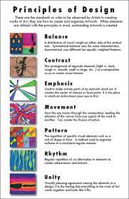 |  |  |  |  |  |  |  |  |  | Reflect on how Principles of Design are applied in nature and manmade environment.
THURSDAY | Review Learners knowledge on the previous lesson. | - Assist Learners to identify examples of Principles of Design in nature.  - Demonstrate drawing examples of Principles of design in nature.  - Learners individually practice drawing examples of Principles of design in nature.  Examples of Principles of design in nature;  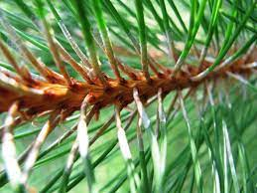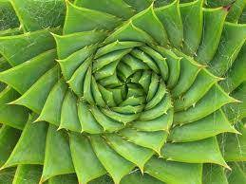    Examples of Principles of design in manmade environment;  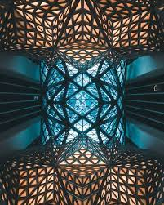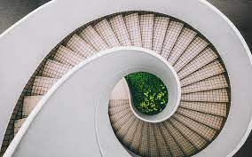   |  |  |  |  |  |  |  |  |  | Learners in small groups to practice drawing examples of Principles of design in manmade environment.  Practical;  Draw 5 examples of Principles of design in Nature and in manmade environment.

Name of Teacher: School: District:

