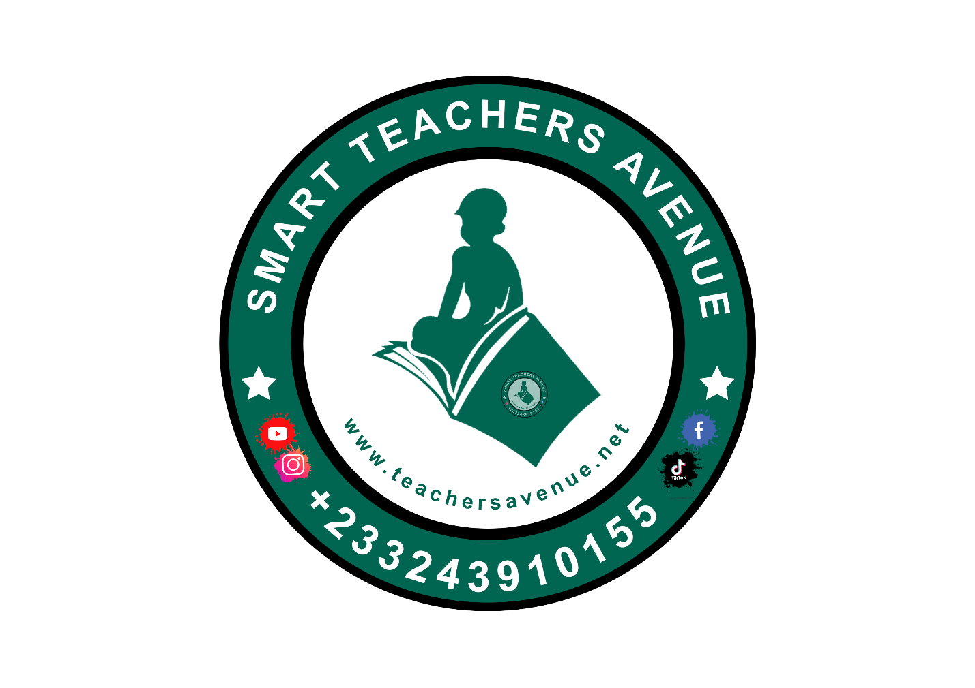

Kindergarten 1

SECOND TERM SCHEME OF LEARNING
ACADEMIC YEAR – 2025/2026
9TH JANUARY TO 1ST APRIL, 2026
SECOND TERM SCHEME - KG ONE
WEEKS | STRAND | SUB STRANDS | CONTENT STANDARD | INDICATORS | RESOURCES
1  9/1/26 | Values And Beliefs | Our Family Values | K1.3.1.1 | K1.3.1.1.1-7 | Poster/ cut out picture depicting peoples from different parts of Ghana. Ghana map,
2  16/1/26 | Values And Beliefs | Our Family Values | K1.3.1.1 | K1.3.1.1.1-7
3  23/1/26 | Values And Beliefs | Our Cultural Value | K1.3.2.1 | K1.3.2.1.1.-5
4  30/1/26 | Values And Beliefs | Our Religious Values | K1.3.3.1 | K1.3.3.1.1-6 | Pictures of three main worships in Ghana, Big book
5  6/2/26 | Values And Beliefs | Our Beliefs | K1.3.4.1 | K1.3.4.1.1-5 | Pictures depicting people from different part of Ghana, Big book
6  13/2/26 | Values And Beliefs | Our Beliefs | K1.3.4.1 | K1.3.4.1.1-5
7  20/2/26 | My Local Community | Knowing The Special Places In Our Local Community | K1.4.1.1 | K1.4.1.1.1-6 | Pictures and videos depicting special places in the community
8  27/2/26 | My Local Community | Knowing Who The Important People/ Occupation In The Community | K1.4.2.1 | K1.4.2.1.1-7 | Poster/ cut out, picture of important individuals in the community. Ghana map,
9  5/3/26 | My Local Community |  | K1.4.2.1 | K1.4.2.1.1-7
10  13/3/26 | My Nation Ghana | Knowing The Special Leaders In Our Community And Country | K1.4.3.1 | K1.4.3.1.1-6 | Pictures and videos of past and present leaders in the community, Big book
11  19/3/26 | My Nation Ghana | History And Celebration Of  Ghana's Independence | K1.5.1.1 | K1.5.1.1.1-8 | Pictures and videos of pre and post-independence of Ghana, big book
12  27/3/26 | REVISION AND END OF TERM ASSESSMENT
13  1/4/26 | VACATION AND SBA ACTIVITIES

ANNUAL SCHEME OF LEARNING - KG ONE
WEEKS | TERM ONE | TERM TWO | TERM THREE
1 | I Am A Wonderful And Unique Creation | Our Family Values | Living And Non-Living Things
2 | The Parts Of The Human Body And Their Function | Our Family Values | Living Things- Animals  (Domestic And Wild)
3 | Caring For The Parts Of My Body | Our Cultural Value | Living Things- Animals  (Domestic And Wild)
4 | Keeping My Body Healthy By Eating Good Food And Taking My Vaccination | Our Religious Values | Water
5 | Keeping My Body Healthy By Eating Good Food And Taking My Vaccination | Our Beliefs | Air
6 | My Environment And My Health | Our Beliefs | Plants
7 | Protecting Ourselves From Home And Road Accidents | Knowing The Special Places In Our Local Community | Plants
8 | Protecting Ourselves From Home And Road Accidents | Knowing Who The Important People/ Occupation In The Community | Gardening
9 | Types And Members Of My Family | Knowing Who The Important People/ Occupation In The Community | Day And Night
10 | Origin And History Of My Family | Knowing The Special Leaders In Our Community And Country | Changing Weather Conditions
11 | Family Celebration And Festivals | History And Celebration Of  Ghana's Independence | Connecting And Communicating With The Global Community
12 | My School Family- Rules And Regulations |  | Connecting And Communicating With The Global Community
13 | My School Family- Rules And Regulations

