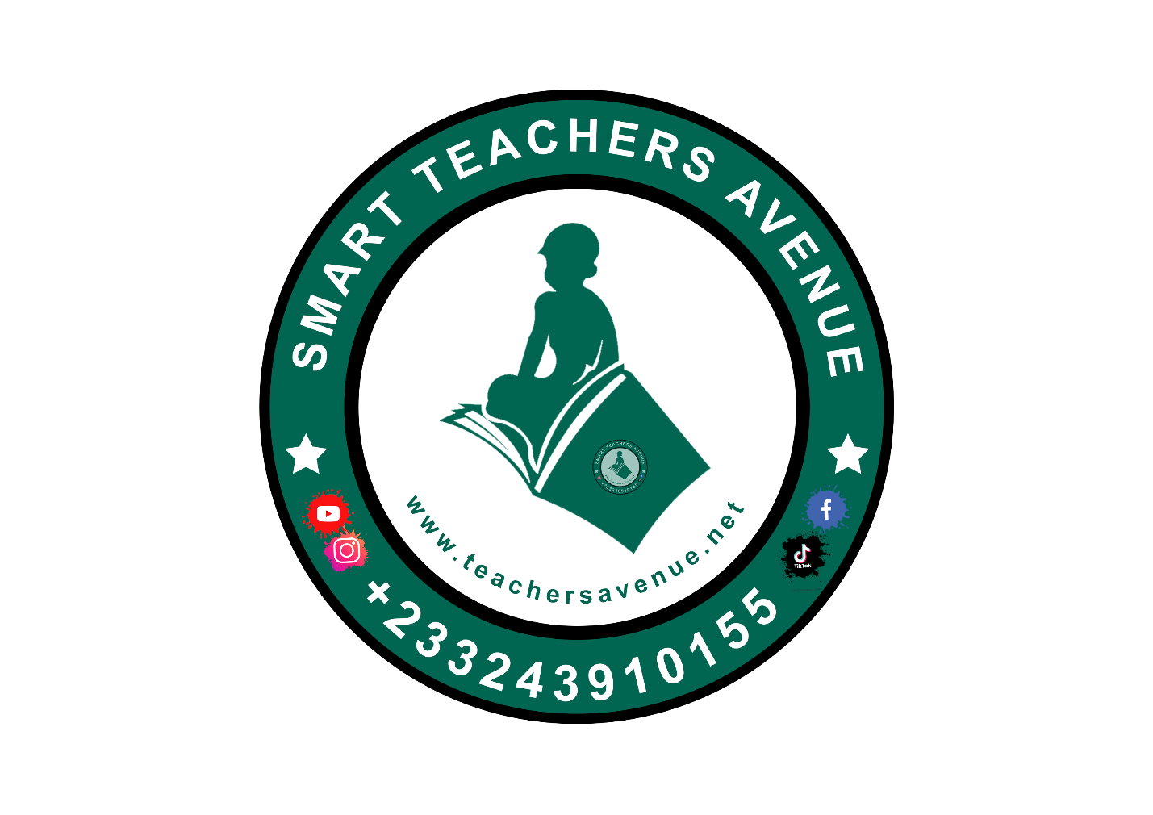
Kindergarten 2

SECOND TERM SCHEME OF LEARNING
ACADEMIC YEAR – 2025/2026
9TH JANUARY TO 1ST APRIL, 2026

SECOND TERM SCHEME - KG TWO
WEEKS | STRAND | SUB STRANDS | CONTENT STANDARD | INDICATORS | RESOURCES
1  9/1/26 | Values And Beliefs | Our Personal Values | K2.3.1.1 | K2.3.1.1.1-6 | Big book, word card and sentence card, pictures and videos,
2  16/1/26 | Values And Beliefs | My Cultural Values | K2.3.2.1 | K2.3.2.1.1-6 | Big book, word card and sentence card, pictures and videos,
3  23/1/26 | Values And Beliefs | Our National And Civic Values | K2.3.3.1 | K2.3.3.1.1-6 | Big book, word card and sentence card, pictures and videos,
4  30/1/26 | Values And Beliefs | Our National And Civic Values | K2.3.3.1 | K2.3.3.1.1-6 | Big book, word card and sentence card, pictures and videos,
5  6/2/26 | Values And Beliefs | Our Beliefs | K2.3.4.1 | K2.3.4.1.1-6 | Big book, word card and sentence card, pictures and videos,
6  13/2/26 | My Local Community | Knowing The Special Places In Our Local Community | K2.4.1.1 | K2.4.1.1.1-7 | Pictures and videos depicting special places in the community
7  20/2/26 | My Local Community | Knowing Who The Important People/ Occupation In The Community | K2.4.2.1 | K2.4.2.1.1-5 | Poster/ cut out, picture of important individuals in the community. Ghana map, Cut out shapes, big books, counters, crayons
8  27/2/26 | My Local Community | Knowing Who The Important People/ Occupation In The Community | K2.4.2.1 | K2.4.2.1.1-5
9  5/3/26 | My Local Community | Knowing The Special Leaders In Our Community And Country | K2.4.3.1 | K2.4.3.1.1-6 | Pictures and videos of past and present leaders in the community, Big book
10  13/3/26 | My Local Community | Knowing The Special Leaders In Our Community And Country | K2.4.3.1 | K2.4.3.1.1-6
11  19/3/26 | My Nation Ghana | History And Celebration Of Ghana | K2.5.1.1 | K2.5.1.1.1-7 | Pictures and videos of pre and post-independence of Ghana, big book
12  27/3/26 | REVISION AND END OF TERM ASSESSMENT
13  1/4/26 | VACATION AND SBA ACTIVITIES

ANNUAL SCHEME OF LEARNING - KG TWO
WEEKS | TERM ONE | TERM TWO | TERM THREE
1 | I Am A Wonderful And Unique Creation | Our Personal Values | Living And Non-Living Things
2 | The Parts Of The Human Body (Both External And Internal) And Their Function | My Cultural Values | Living Things-Animals (domestic and wild)
3 | Personal Hygiene And Caring For The Parts Of The Body | Our National And Civic Values | Living Things-Animals (domestic and wild)
4 | Keeping My Body Healthy And Eating Good Food And Taking My Vaccination | Our National And Civic Values | Water
5 | My Environment And My Health | Our Beliefs | Air
6 | Protecting Ourselves From Road Accidents And Harmful Strangers | Knowing The Special Places In Our Local Community | Plants
7 | Protecting Ourselves From Road Accidents And Harmful Strangers | Knowing Who The Important People/ Occupation In The Community | Plants
8 | Types And Members Of My Family | Knowing Who The Important People/ Occupation In The Community | Types Of Soil And Gardening
9 | Family History | Knowing The Special Leaders In Our Community And Country | Natural & Man-Made (Artificial) Sources Of Light
10 | Family Celebration And Festivals | Knowing The Special Leaders In Our Community And Country | Changing Weather Conditions
11 | Family Celebration And Festivals | History And Celebration Of Ghana | Connecting & Communicating With The Global Community
12 | My School Family | History And Celebration Of Ghana | Financial literacy: Buying and Selling
13 | My School Family

